AWS Assignment – Complete Step-by-Step Lab Guide
This document follows the exact assignment flow. Paste your screenshots below each step.
Task 1: Create a VPC in N. Virginia (us-east-1)

Procedure
1. Sign in to AWS Console.
2. Select the N. Virginia (us-east-1) region.
3. Open VPC Dashboard.
4. Click Create VPC.
5. Choose 'VPC only'.
6. Enter a Name tag.
7. Enter IPv4 CIDR block (Example: 10.0.0.0/16).
8. Click Create VPC.

Screenshot(s)
Created VPC
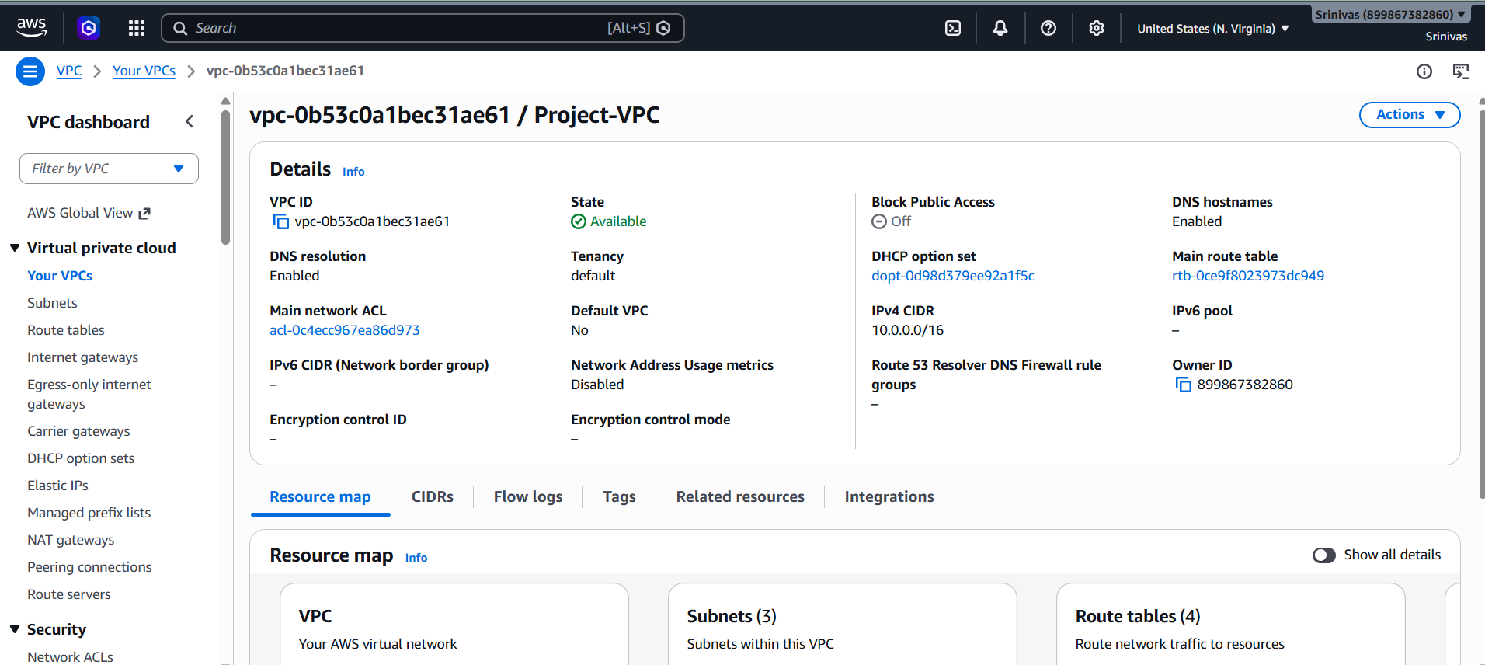

Task 2: Create Two Subnets

Procedure
1. Open Subnets.
2. Click Create subnet.
3. Select the VPC.
4. Create Public Subnet (enable auto-assign public IP if required).
5. Create Private Subnet in another Availability Zone or same as instructed.
6. Click Create subnet.

Screenshot(s)
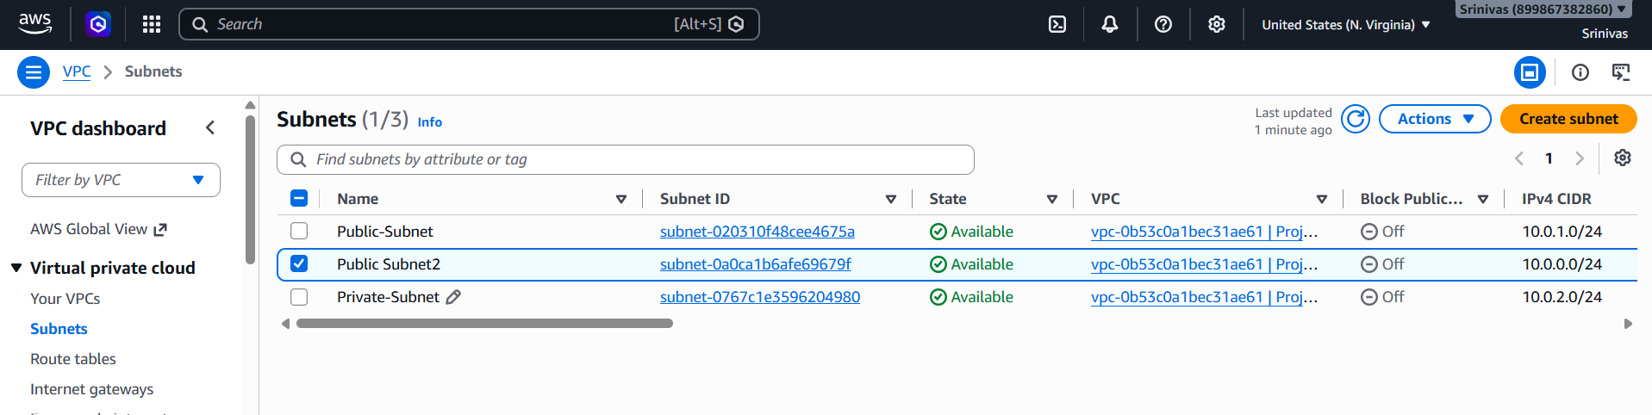
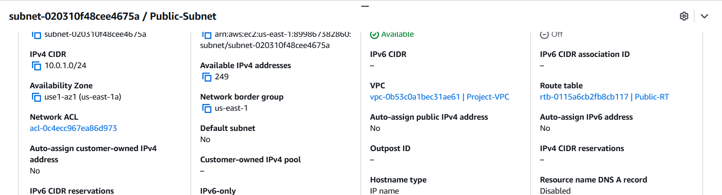
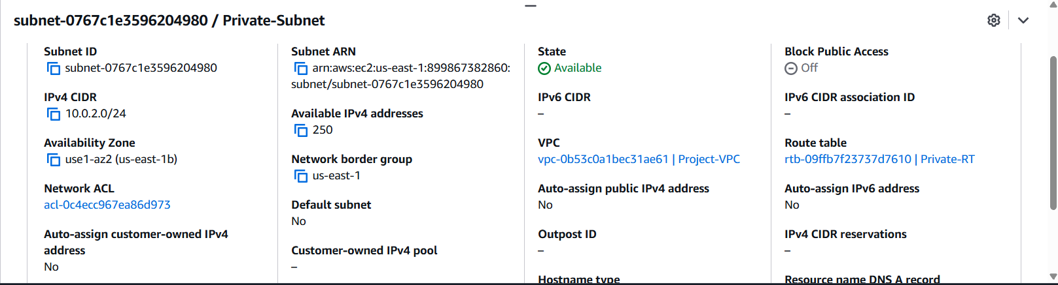

Task 3: Attach an Internet Gateway

Procedure
1. Open Internet Gateways.
2. Click Create Internet Gateway.
3. Provide a name.
4. Create the gateway.
5. Choose Actions → Attach to VPC.
6. Select your VPC and attach.

Screenshot(s)
Internet Gateway
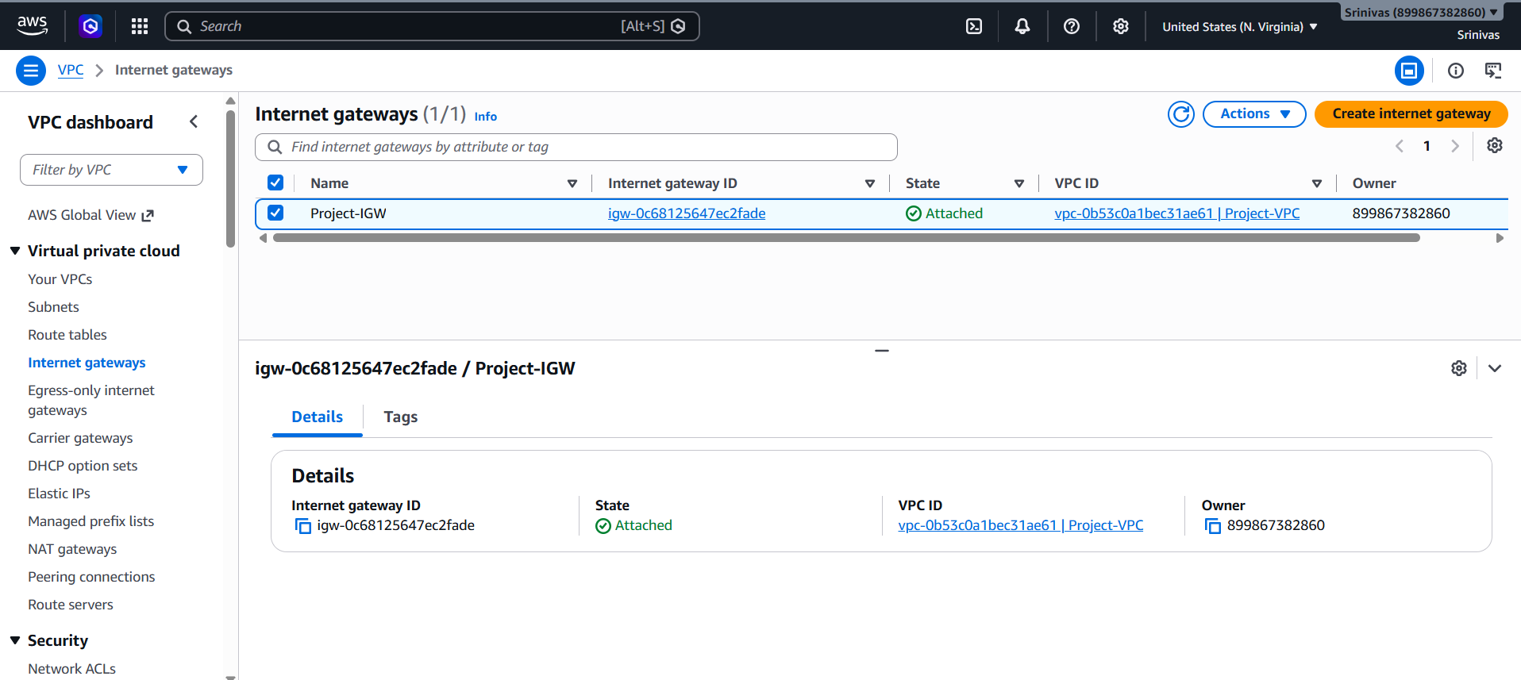

Task 4: Create Public and Private Route Tables

Procedure
1. Open Route Tables.
2. Create Public Route Table.
3. Add route 0.0.0.0/0 to Internet Gateway.
4. Associate the Public Subnet.
5. Create Private Route Table.
6. Associate the Private Subnet.

Screenshot(s)
Public Route Table
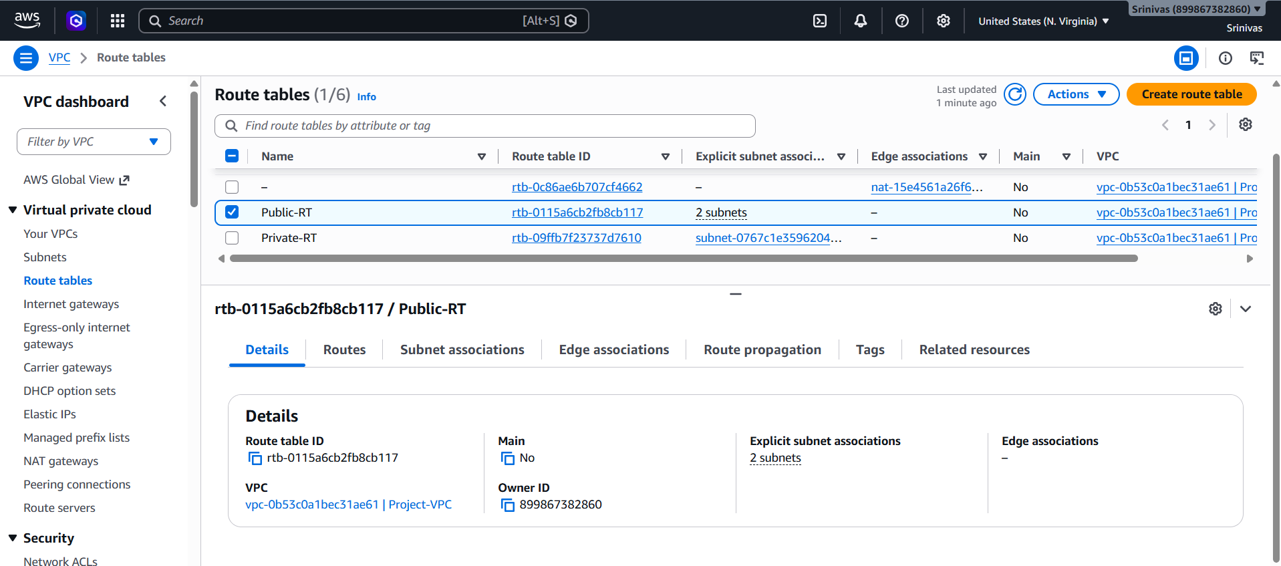
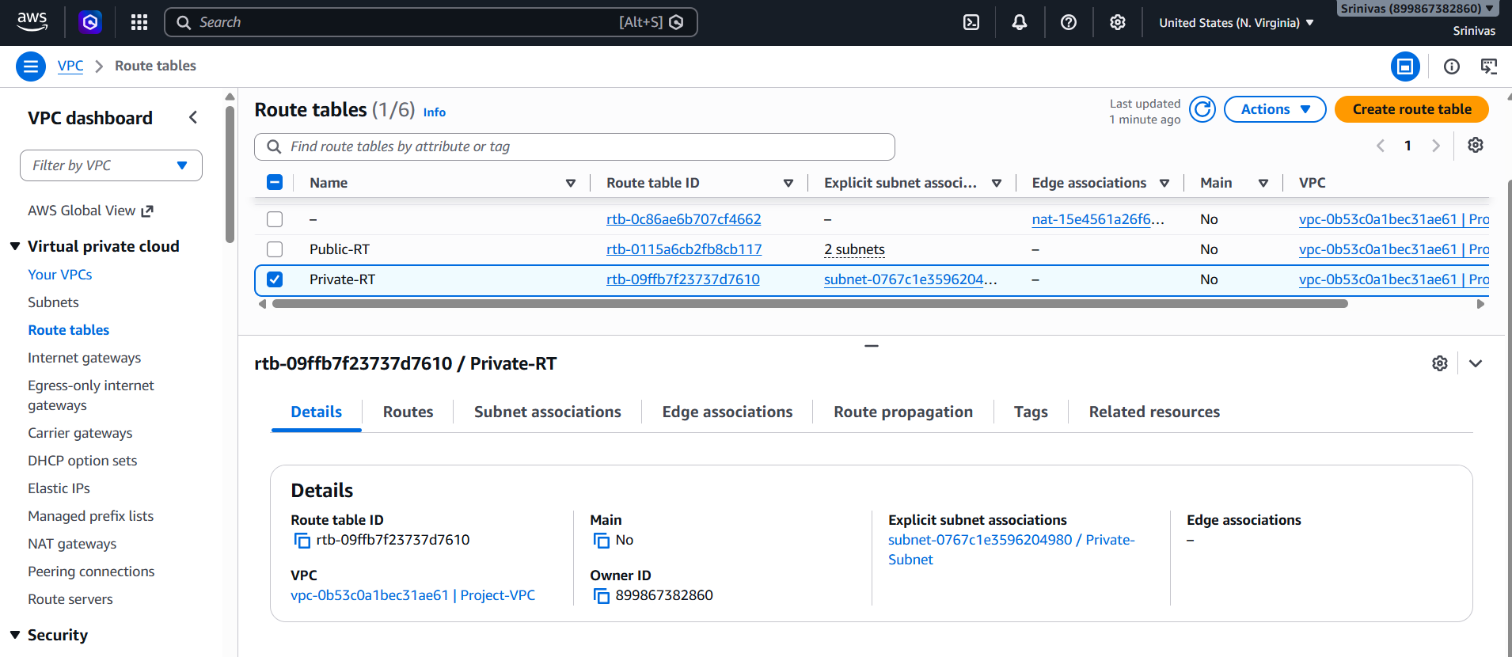

Task 5: Create NAT Gateway

Procedure
1. Open NAT Gateways.
2. Click Create NAT Gateway.
3. Select the Public Subnet.
4. Allocate an Elastic IP.
5. Create NAT Gateway.
6. Open the Private Route Table.
7. Add route 0.0.0.0/0 pointing to the NAT Gateway.
8. Save changes.

Screenshot(s)
NAT Gateway
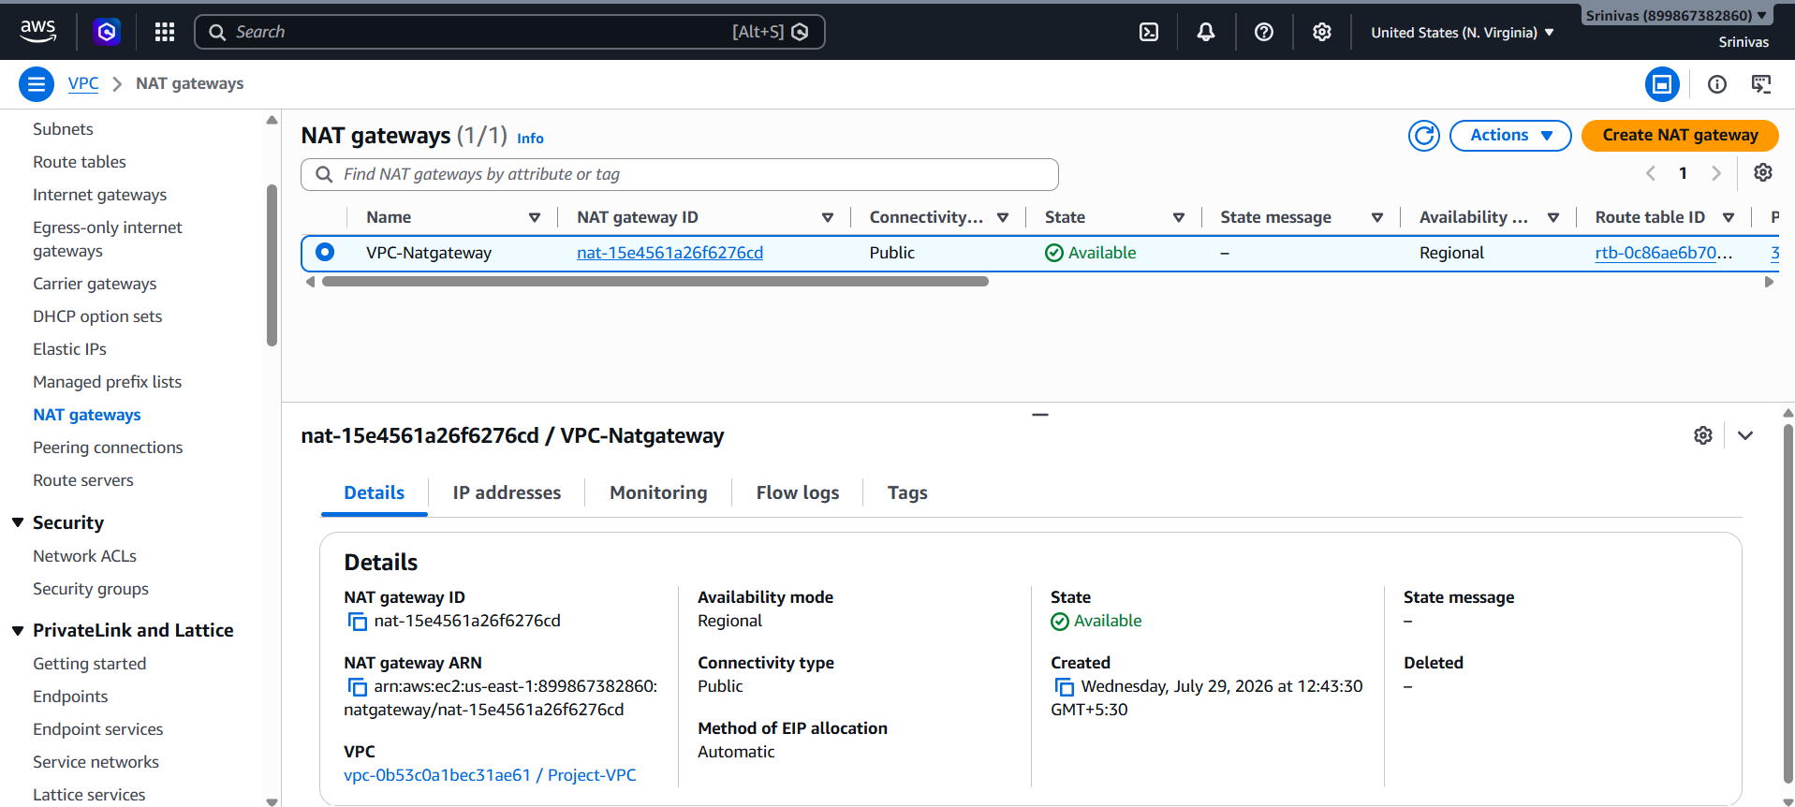

Task 6: Launch Two EC2 Instances

Procedure
1. Launch one EC2 in the Public Subnet with a Public IP.
2. Launch another EC2 in the Private Subnet without a Public IP.
3. Configure Security Groups.
4. Create/choose a Key Pair.
5. Launch both instances.

Screenshot(s)
Public EC2
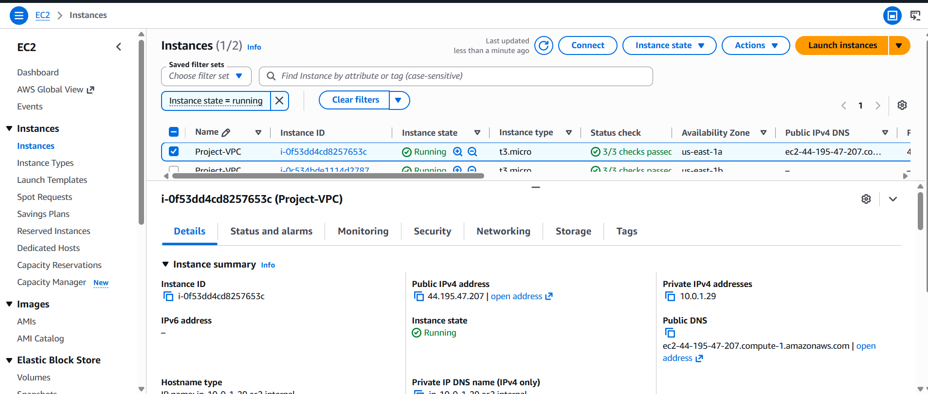
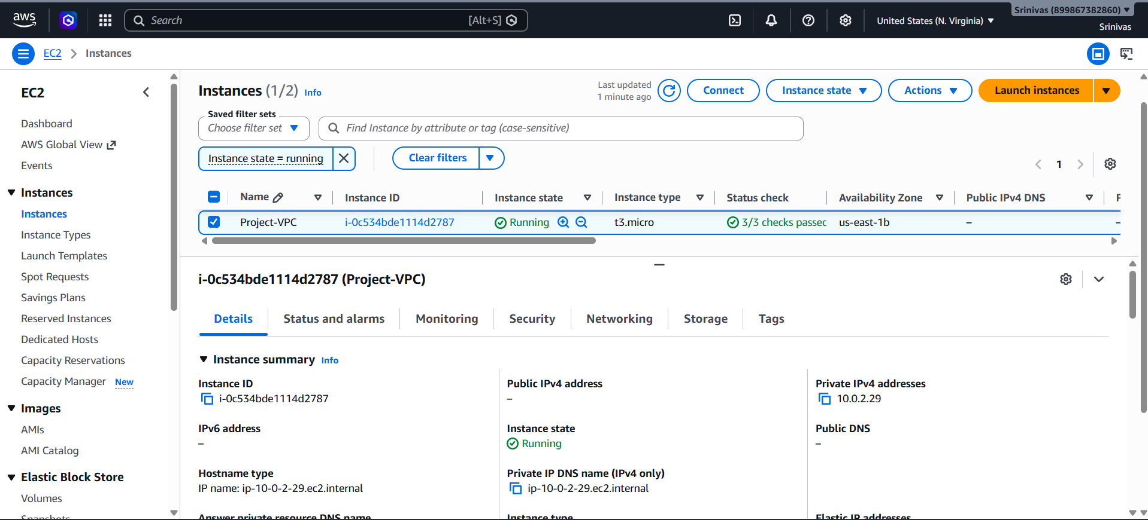

Task 7: Install Apache on Both EC2 Instances

Procedure
1. Connect to the EC2 instance.
2. Install Apache.
3. Start and enable the Apache service.
4. Create a sample index.html page.
5. Repeat for the second instance.
6. Verify the webpage opens.

Screenshot(s)
Apache installation
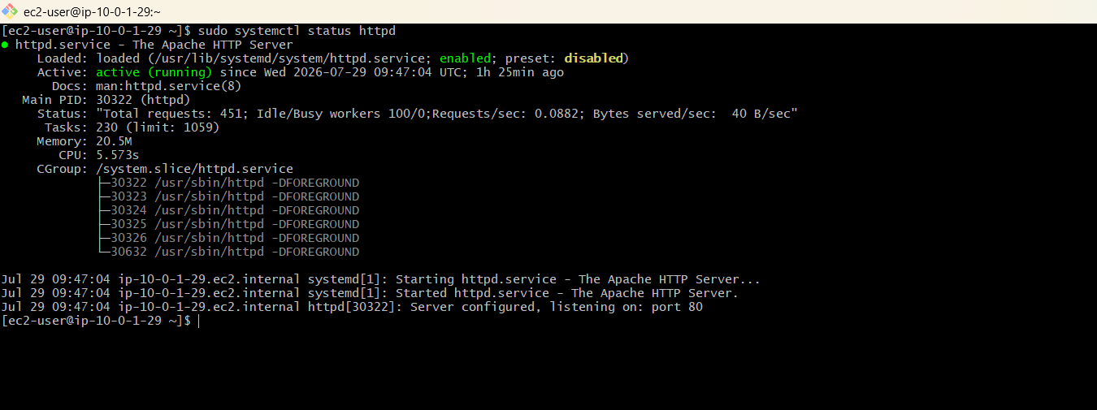
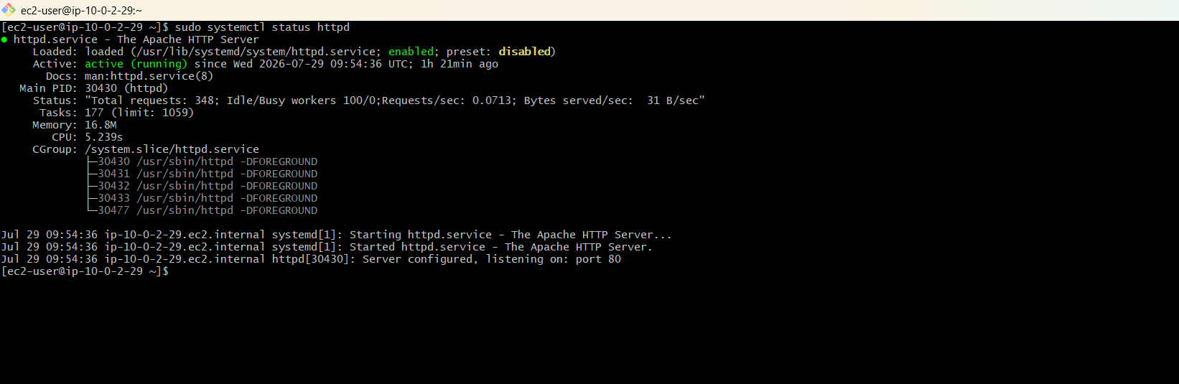

Task 8: Create an Application Load Balancer

Procedure
1. Create a Target Group.
2. Register both EC2 instances.
3. Verify target health is Healthy.
4. Create an Internet-facing Application Load Balancer.
5. Select two Public Subnets.
6. Attach the Target Group.
7. Test the ALB DNS in a browser.

Screenshot(s)
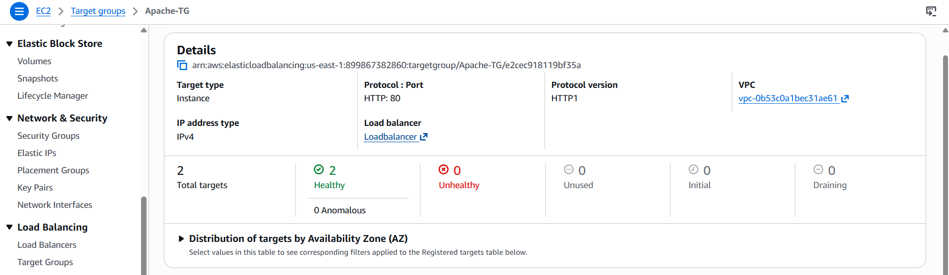
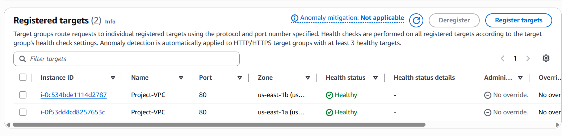
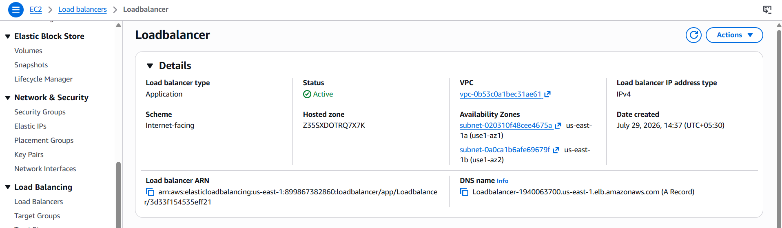
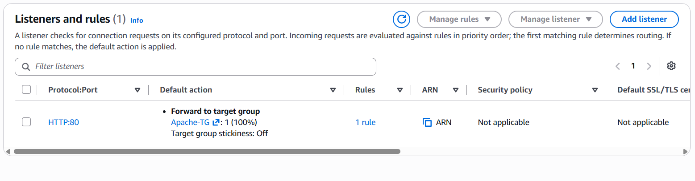
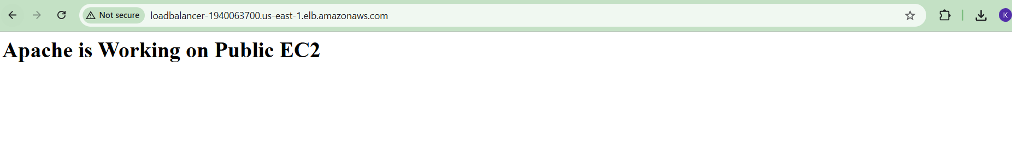

Task 9: Store ALB Logs in Amazon S3

Procedure
1. Create an S3 bucket.
2. Add the required bucket policy.
3. Open the ALB Attributes.
4. Enable Access Logs.
5. Select the S3 bucket.
6. Generate traffic.
7. Verify .log.gz files are stored in S3.

Screenshot(s)
S3 Bucket
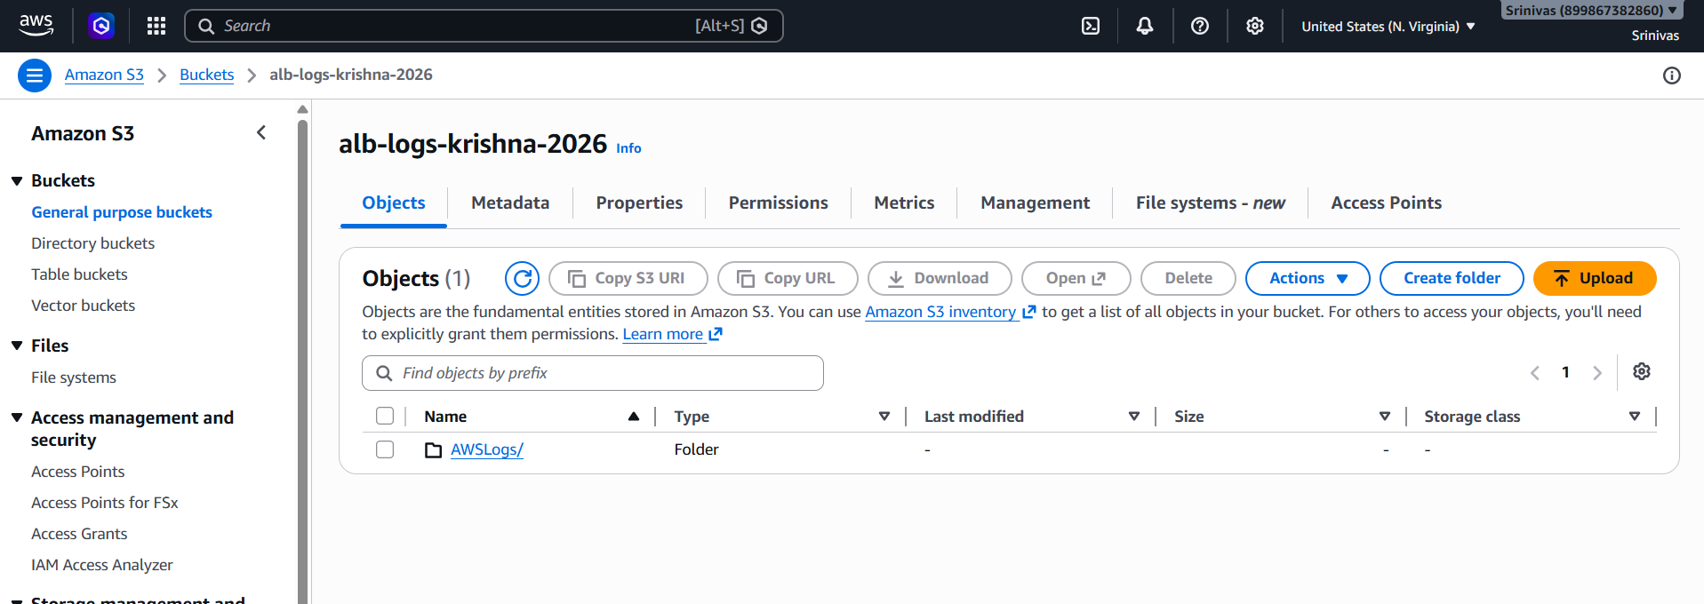
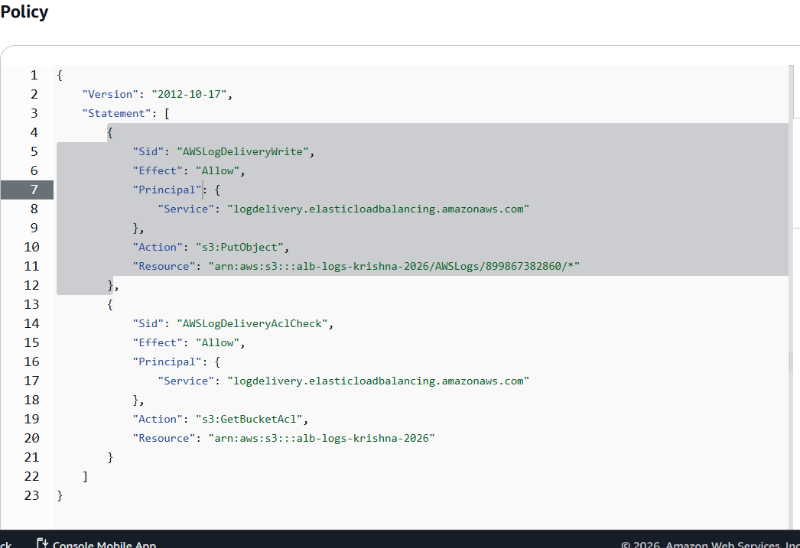

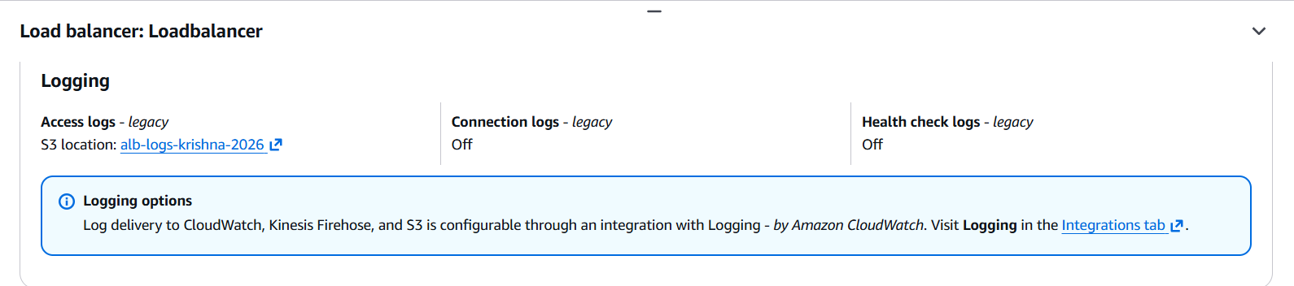

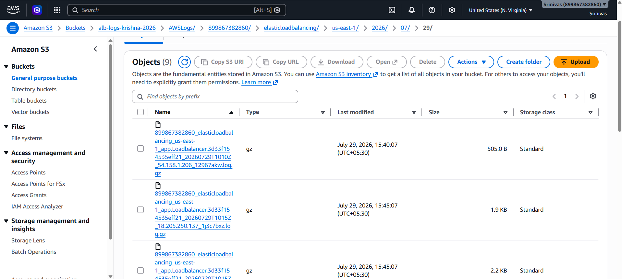

Task 10: Store VPC Flow Logs in CloudWatch

Procedure
1. Open the VPC.
2. Choose Flow Logs.
3. Create a Flow Log.
4. Select CloudWatch Logs as the destination.
5. Create or choose a Log Group.
6. Save the Flow Log.
7. Verify logs appear in CloudWatch.

Screenshot(s)
VPC Flow Log
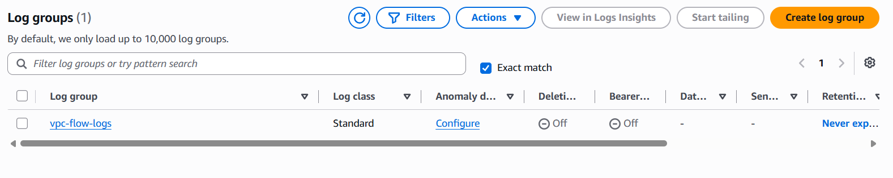
CloudWatch Log Group
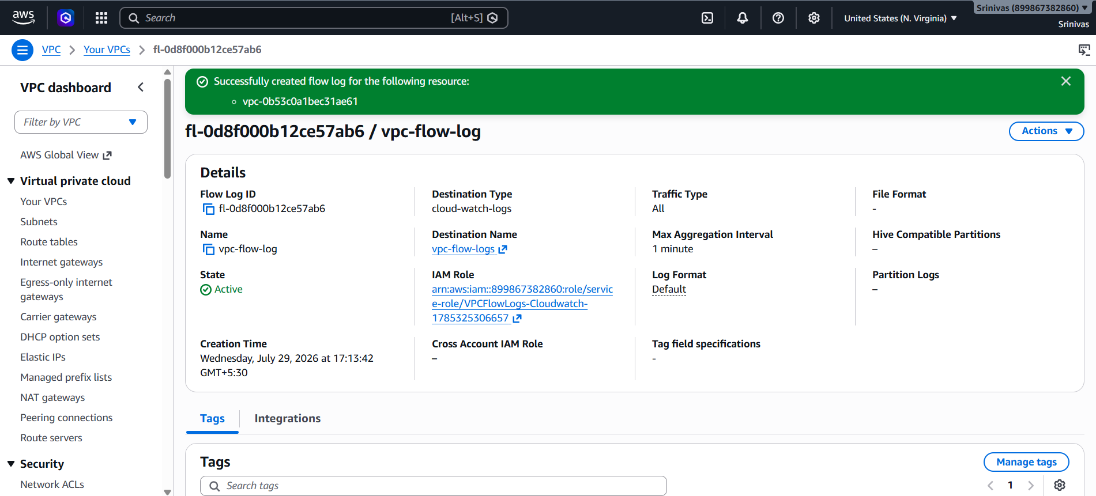
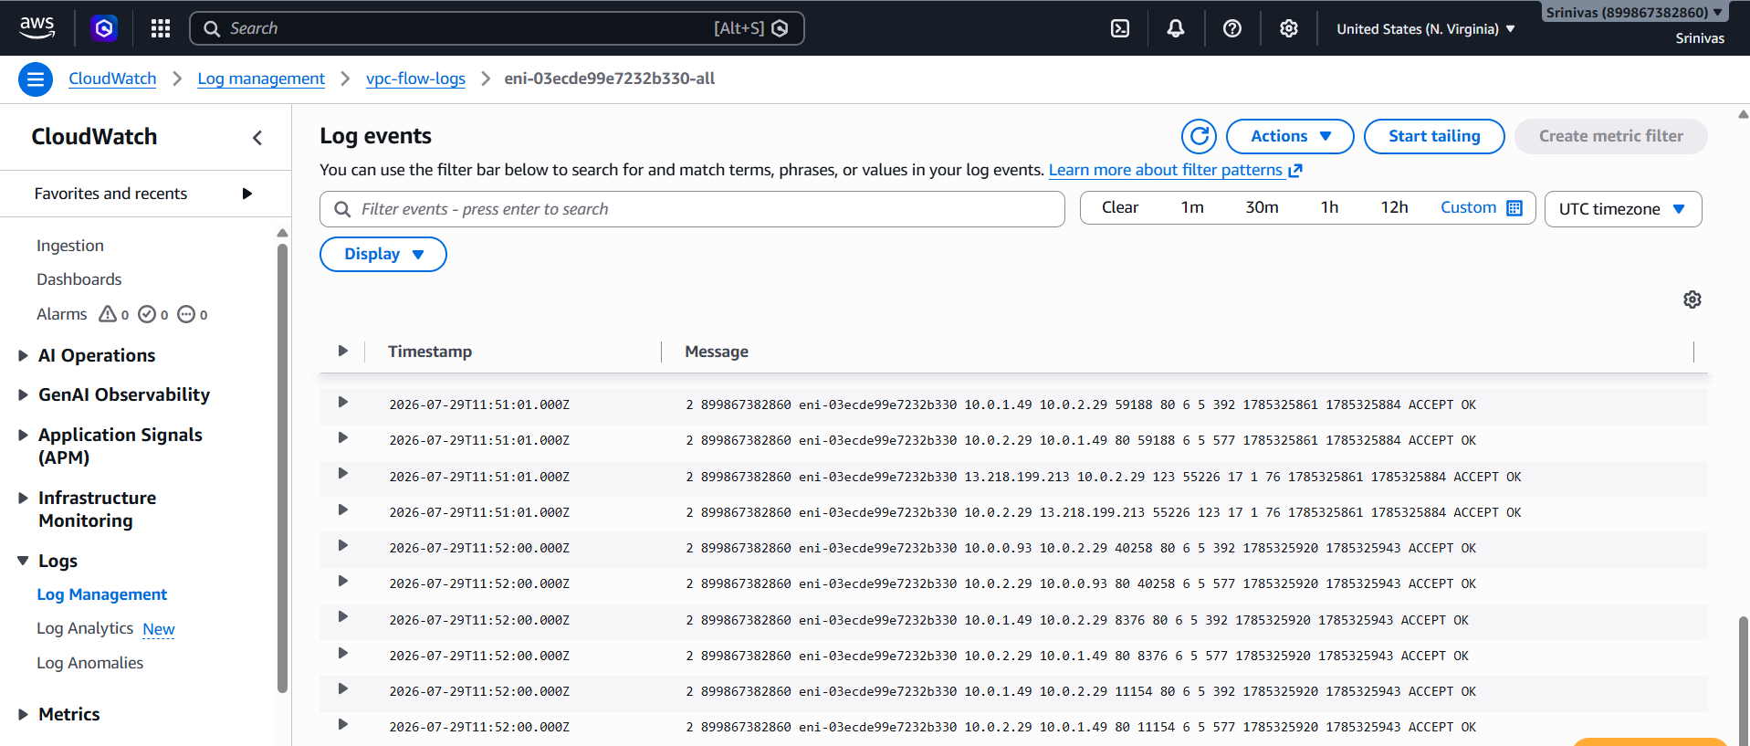

Task 11: Create CloudWatch Dashboards

Procedure
1. Open CloudWatch.
2. Create a Dashboard.
3. Add a CPU Utilization widget for the EC2 instances.
4. Add Apache monitoring (using CloudWatch Agent or custom metric if configured).
5. Save the dashboard.

Screenshot(s)
CloudWatch Dashboard
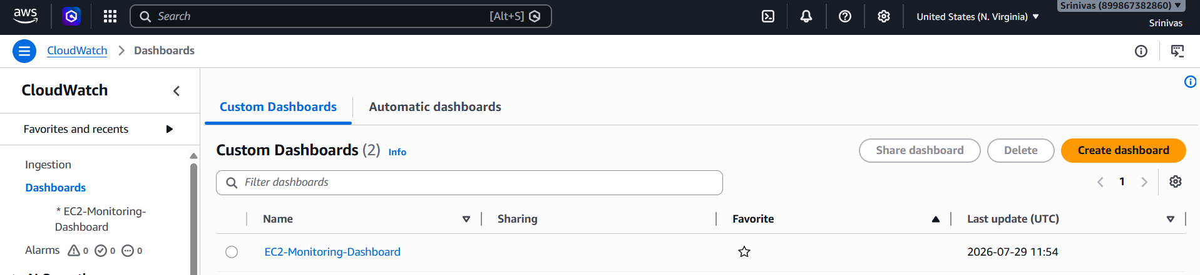
CPU Widget
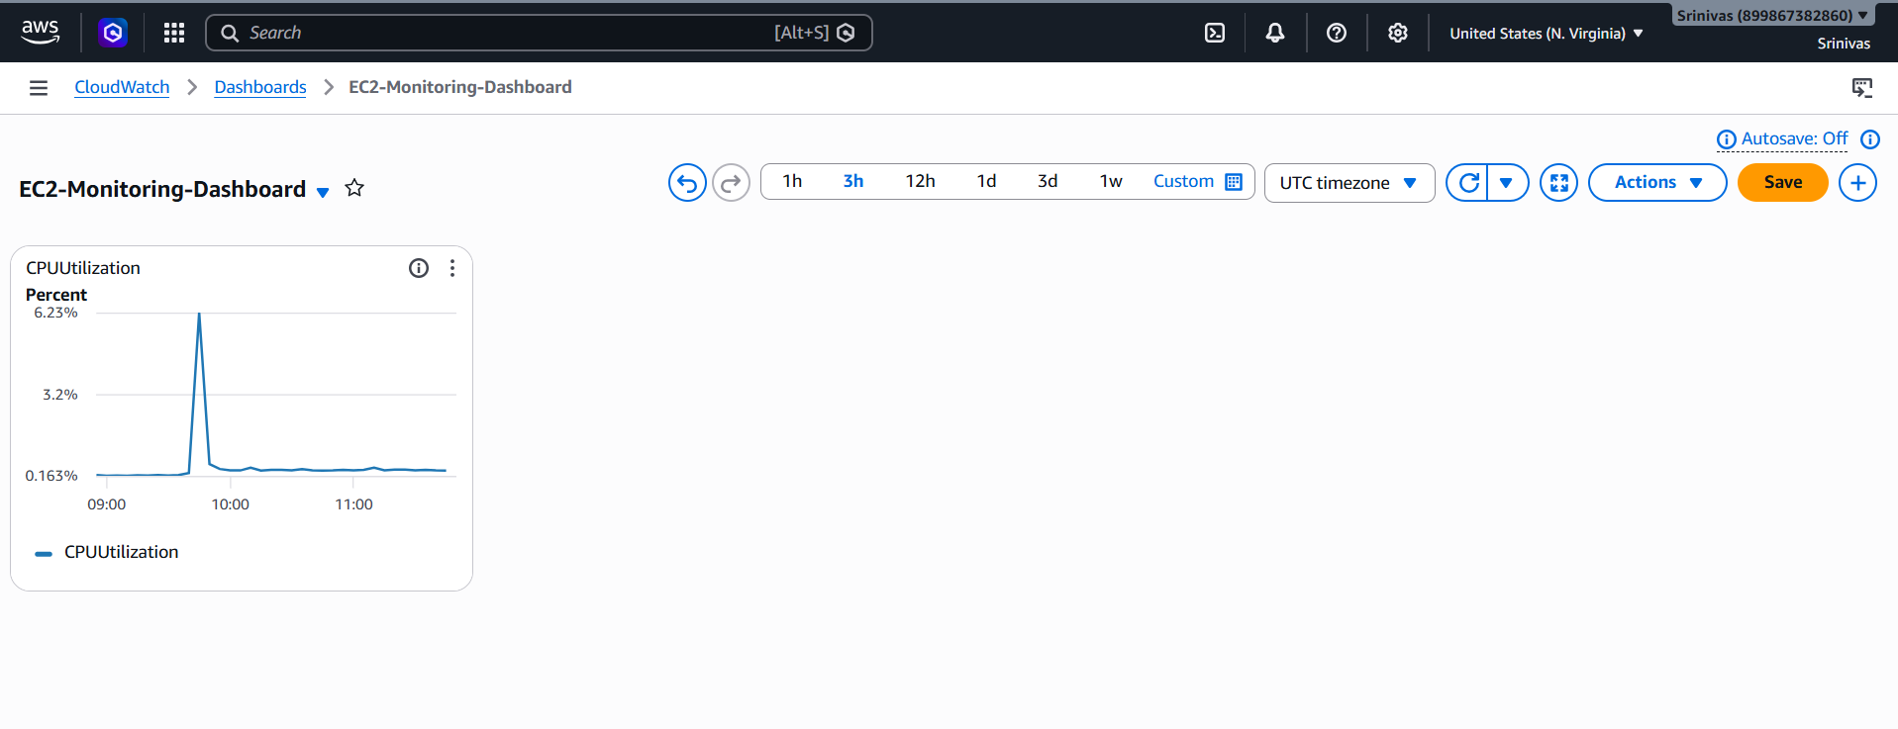
Apache Widget
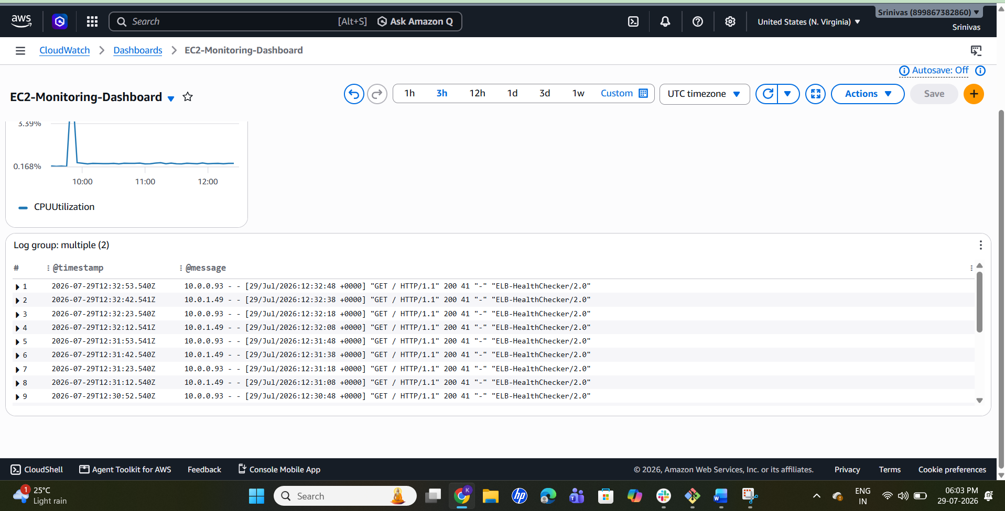

Task 12: Configure Auto Scaling

Procedure
1. Create a Launch Template from the existing EC2 configuration.
2. Create an Auto Scaling Group.
3. Select the VPC and Public Subnets.
4. Attach the Application Load Balancer.
5. Configure a scaling policy.
6. Set a CloudWatch alarm: CPU Utilization > 70%.
7. Verify a new instance launches when the alarm is triggered.

Screenshot(s)
Launch Template
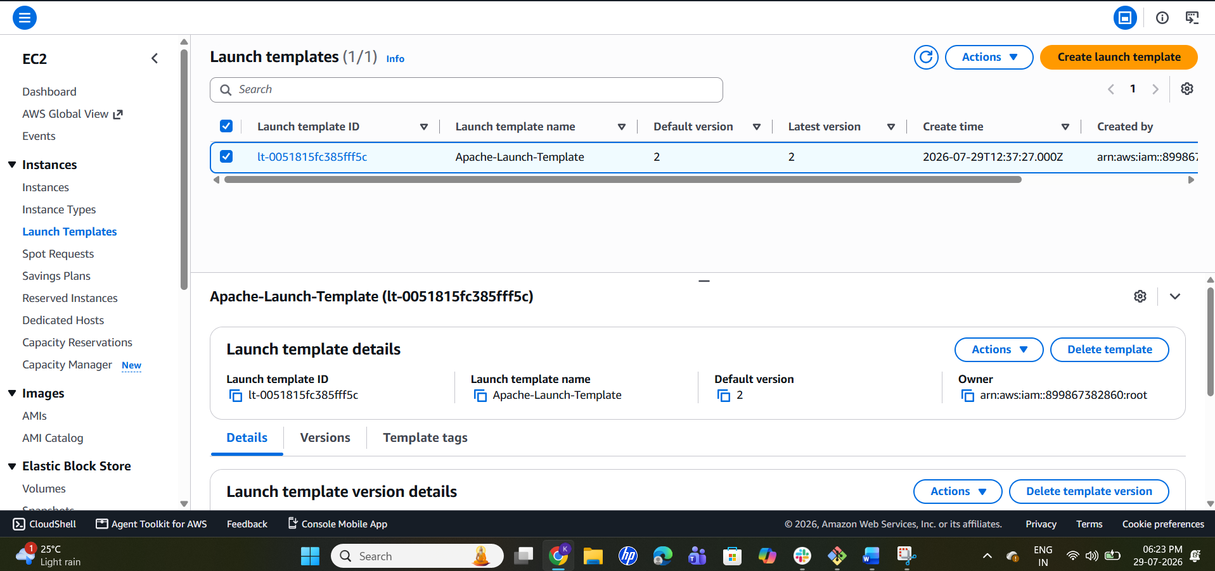
______________________________________________
Auto Scaling Group
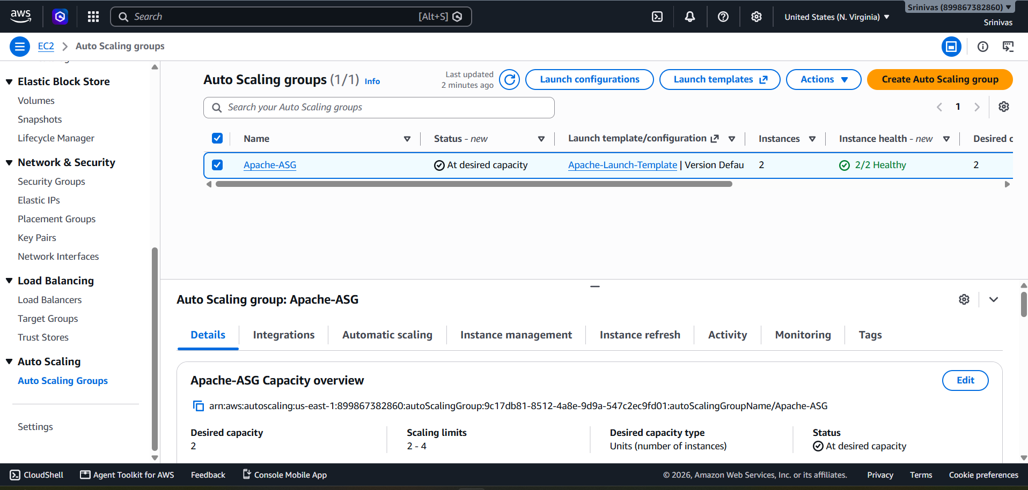
Scaling Policy
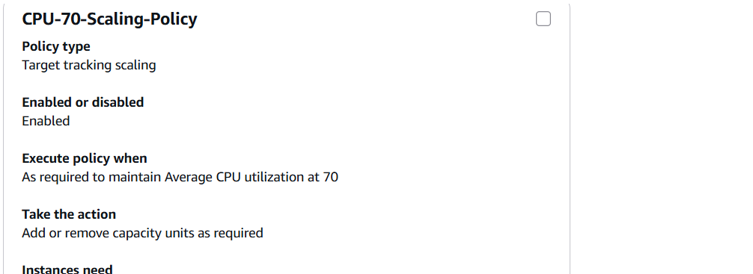
CloudWatch Alarm
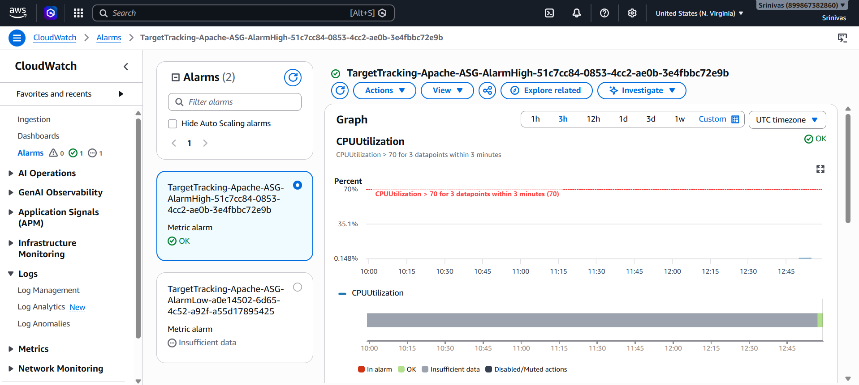
New EC2 Instance
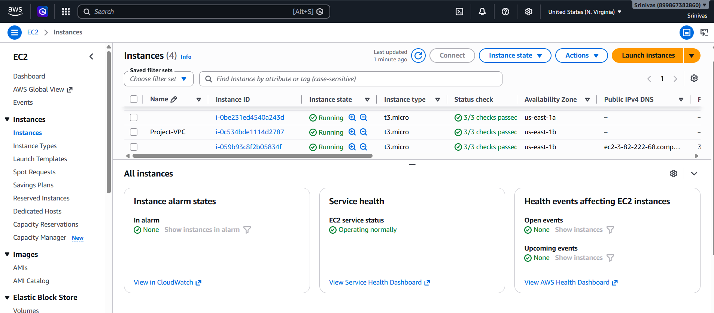

Final Result

Procedure
1. Verify all tasks are completed successfully.
2. Confirm ALB distributes traffic.
3. Confirm ALB logs are stored in S3.
4. Confirm VPC Flow Logs are stored in CloudWatch.
5. Confirm Dashboard displays metrics.
6. Confirm Auto Scaling launches a new instance when CPU exceeds 70%.

